**ASSIGNMENTS ON DIGITAL MARKETING**

**NAME :** ANJU S

**DEPARTMENT :** BE COMPUTER SCIENCE

**COLLEGE :** 8151 DHANALAKSHMI SRINIVASAN INSTITUTE OF

TECHNOLOGY

**NAANMUDHALVAN COURSE**: DIGITAL MARKETING

**NM ID : : 996188C529CA38A6FD453A77A4C7D**

**ASSIGNMENT 1:**

Create a blog or website using Blogspot and WordPress. Customize

the theme design and post new article with 500 words

[**https://newfashioneras.blogspot.com/**](https://newfashioneras.blogspot.com/)

**ASSIGNMENT 2:**

Create a new Facebook business Page and Post one social media poster for your brand

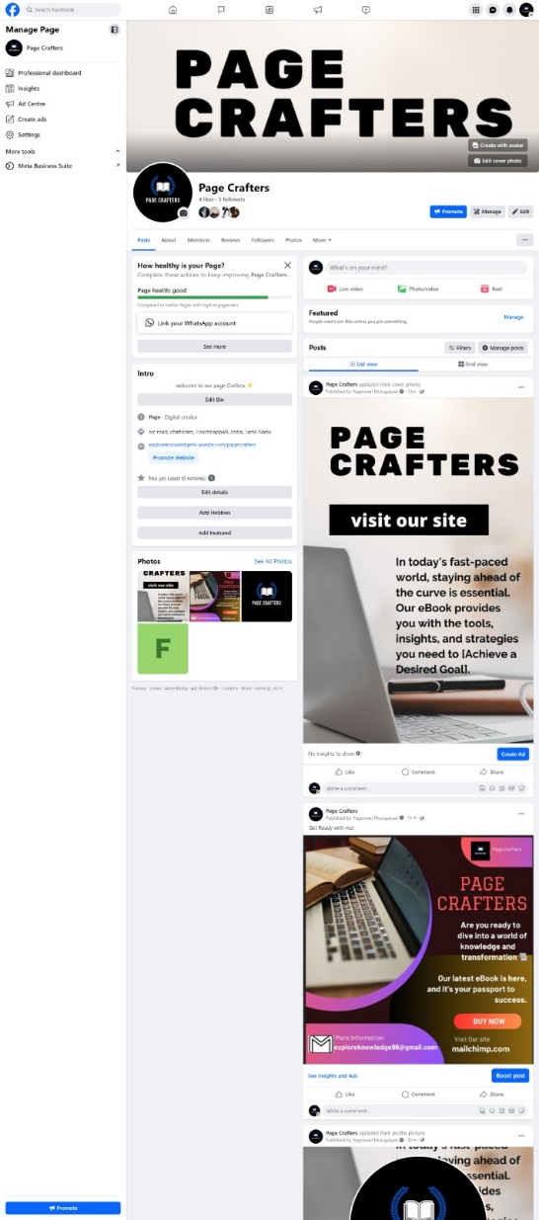

[**https://www.facebook.com/people/Page-Crafters/61550192768049/**](https://www.facebook.com/people/Page-Crafters/61550192768049/)

**ASSIGNMENT 3:**

Create and design a social media advertisement poster using Canva.

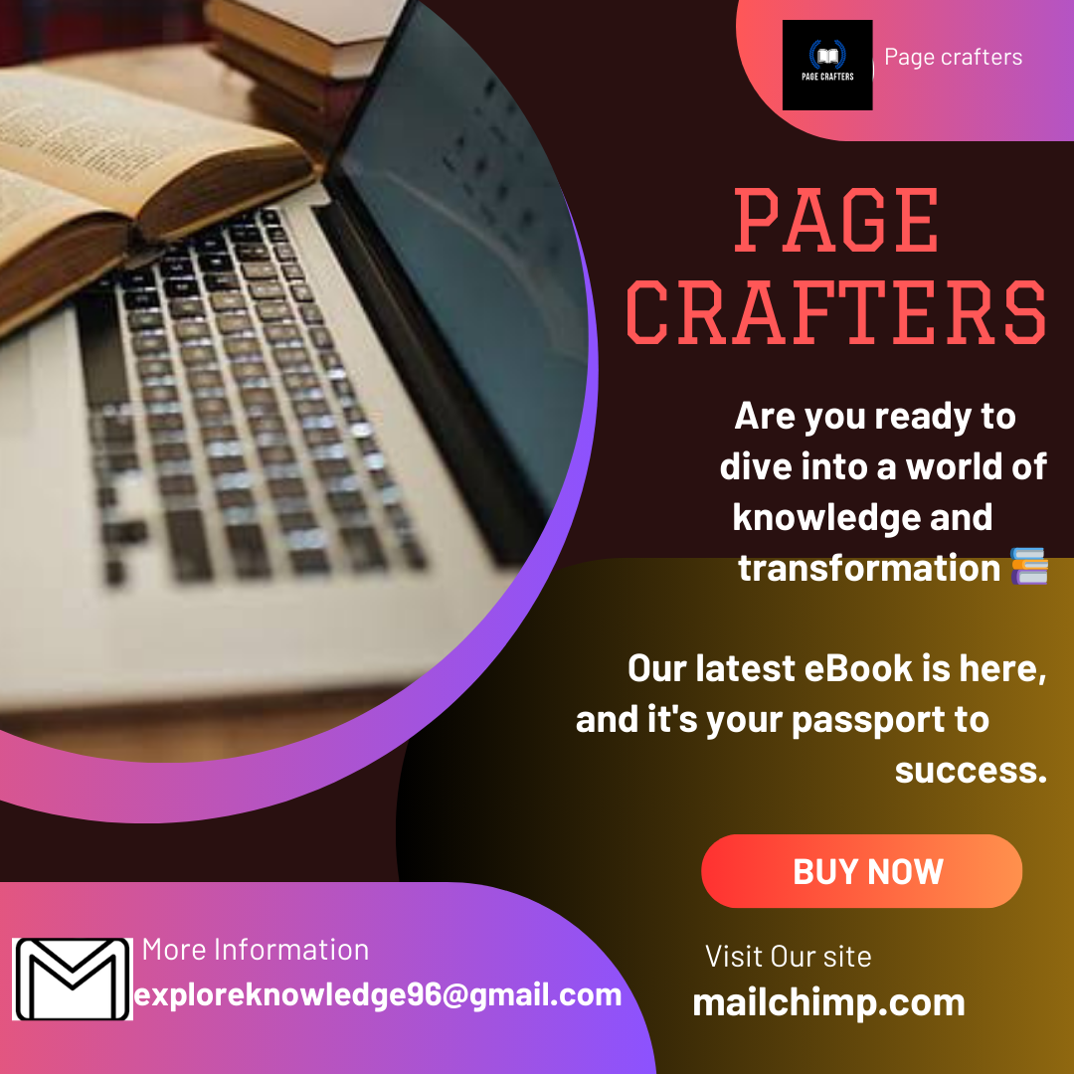

**ASSIGNMENT 4:**

4.Create email newsletter design using MailChimp or Canva tool.

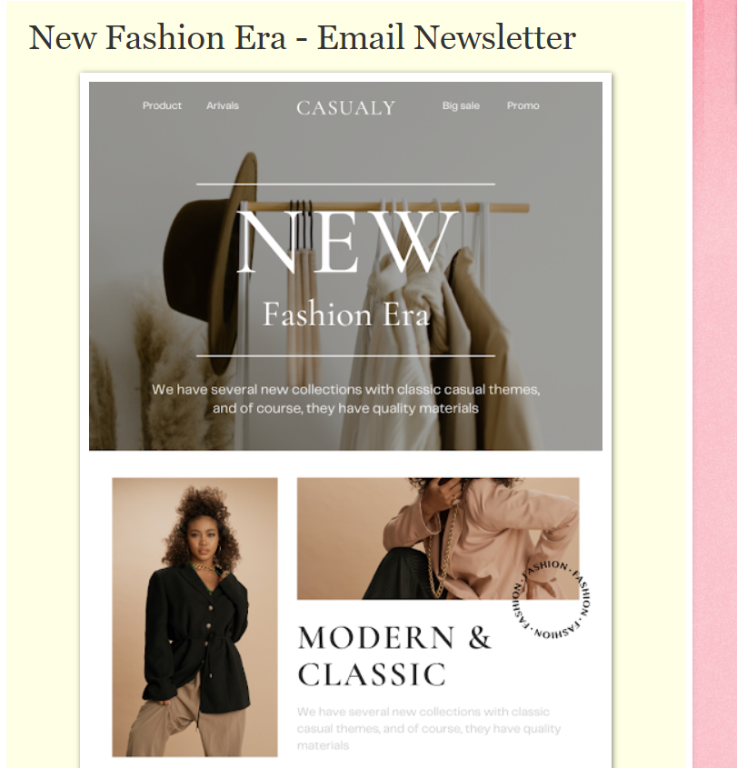

[**https://newfashioneras.blogspot.com/2023/09/new-fashion-era-email-newsletter.html**](https://newfashioneras.blogspot.com/2023/09/new-fashion-era-email-newsletter.html)